|  |
| --- |
| Student |
| -name: String  - birthYear: int  - age: int  - gender: String |
| +Student(nameIn: String, birthYear: int, genderIn: String)  +Student()  +setName(newName: String) void  +setBirthYear(newYear:int) void  +setAge(newAge: int) void  +setGender(newGender:String) void  +getName():String  +getBirthYear(): int  +computeAge():int  +getAge():int  +getGender():String  +toString():String |

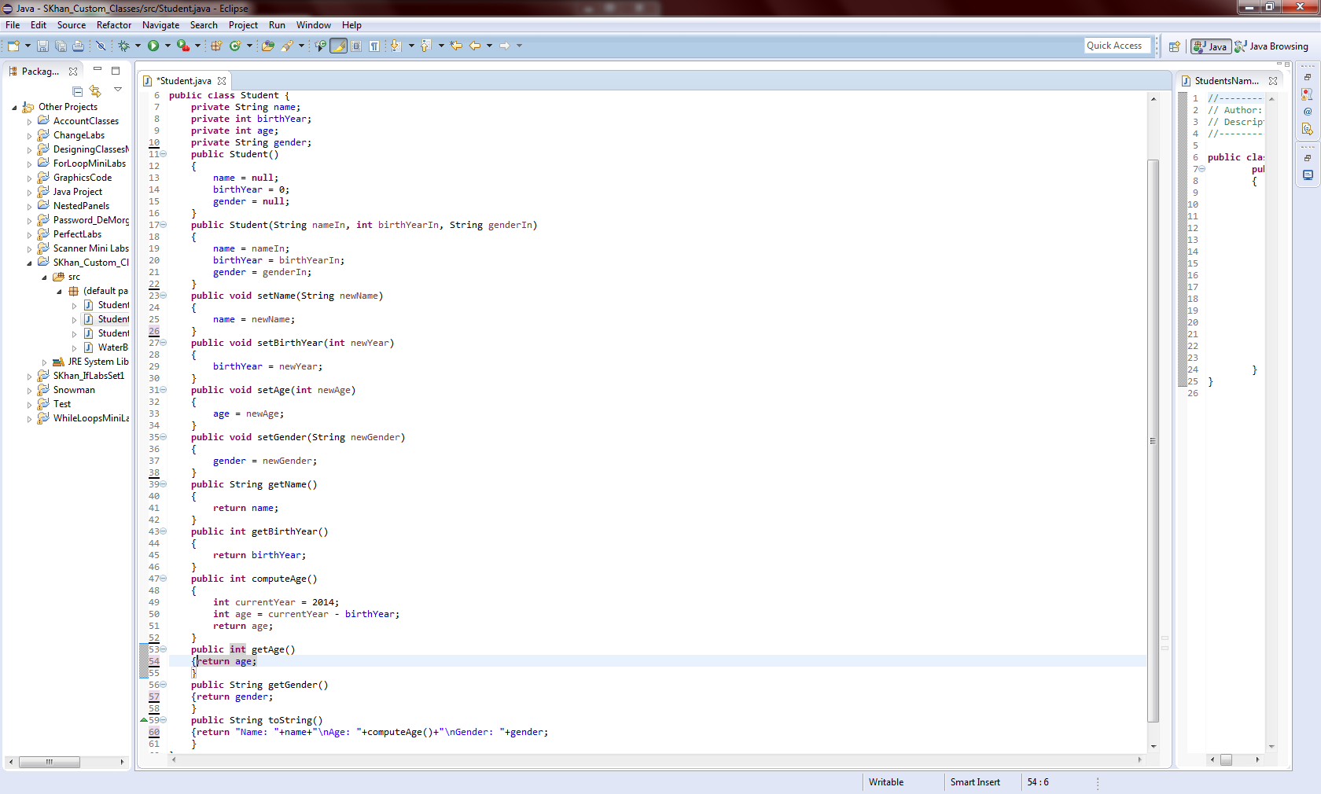

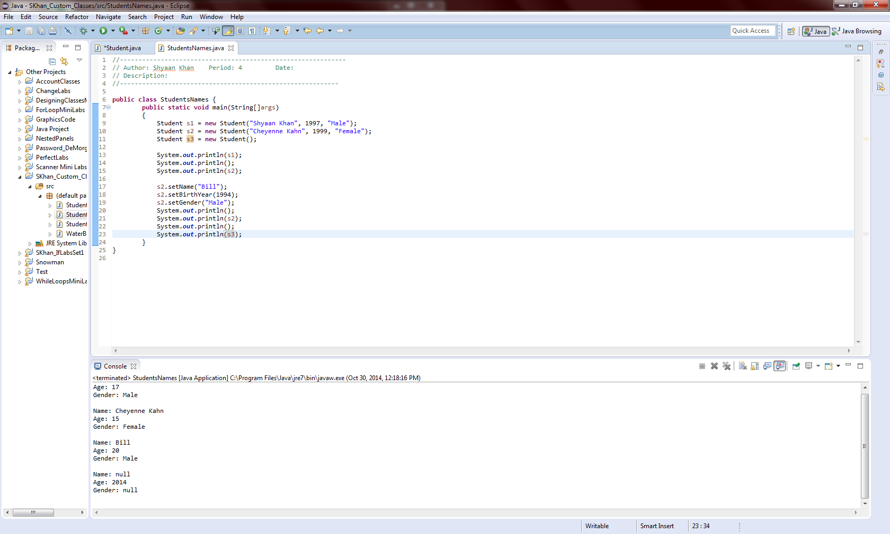

|  |
| --- |
| WaterBottle |
| -hasWaterBottle: boolean  - color: String  - brand: String |
| +WaterBottle(hasWaterBottleIn: Boolean, colorIn:String, brandIn: String)  +WaterBottle(hasWaterBottleIn: boolean)  +setHasWaterBottle(newBottle: boolean) void  +setColor(newColor:String) void  +setBrand(newBrand: int) void  +getHasWaterBottle():boolean  +getColor(): String  +getBrand ():String  +toString():String |

